SCENERIO
LOGIN WITH VALID CREDENTIAL ID PASSWARD

Login with valid credentials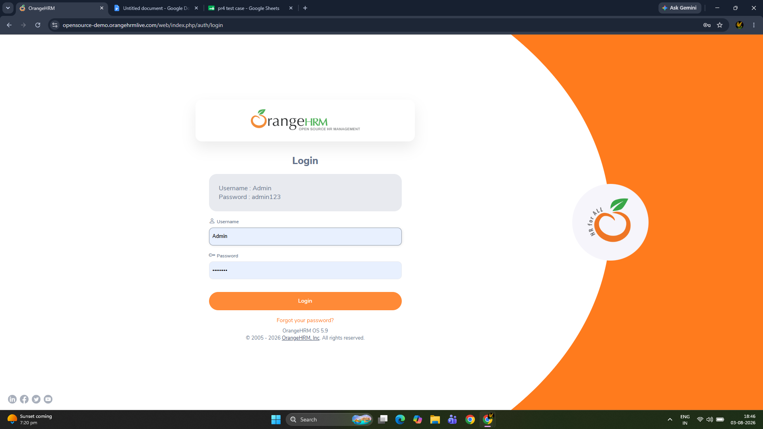
LOGIN WITH INVALID CREDENTIAL 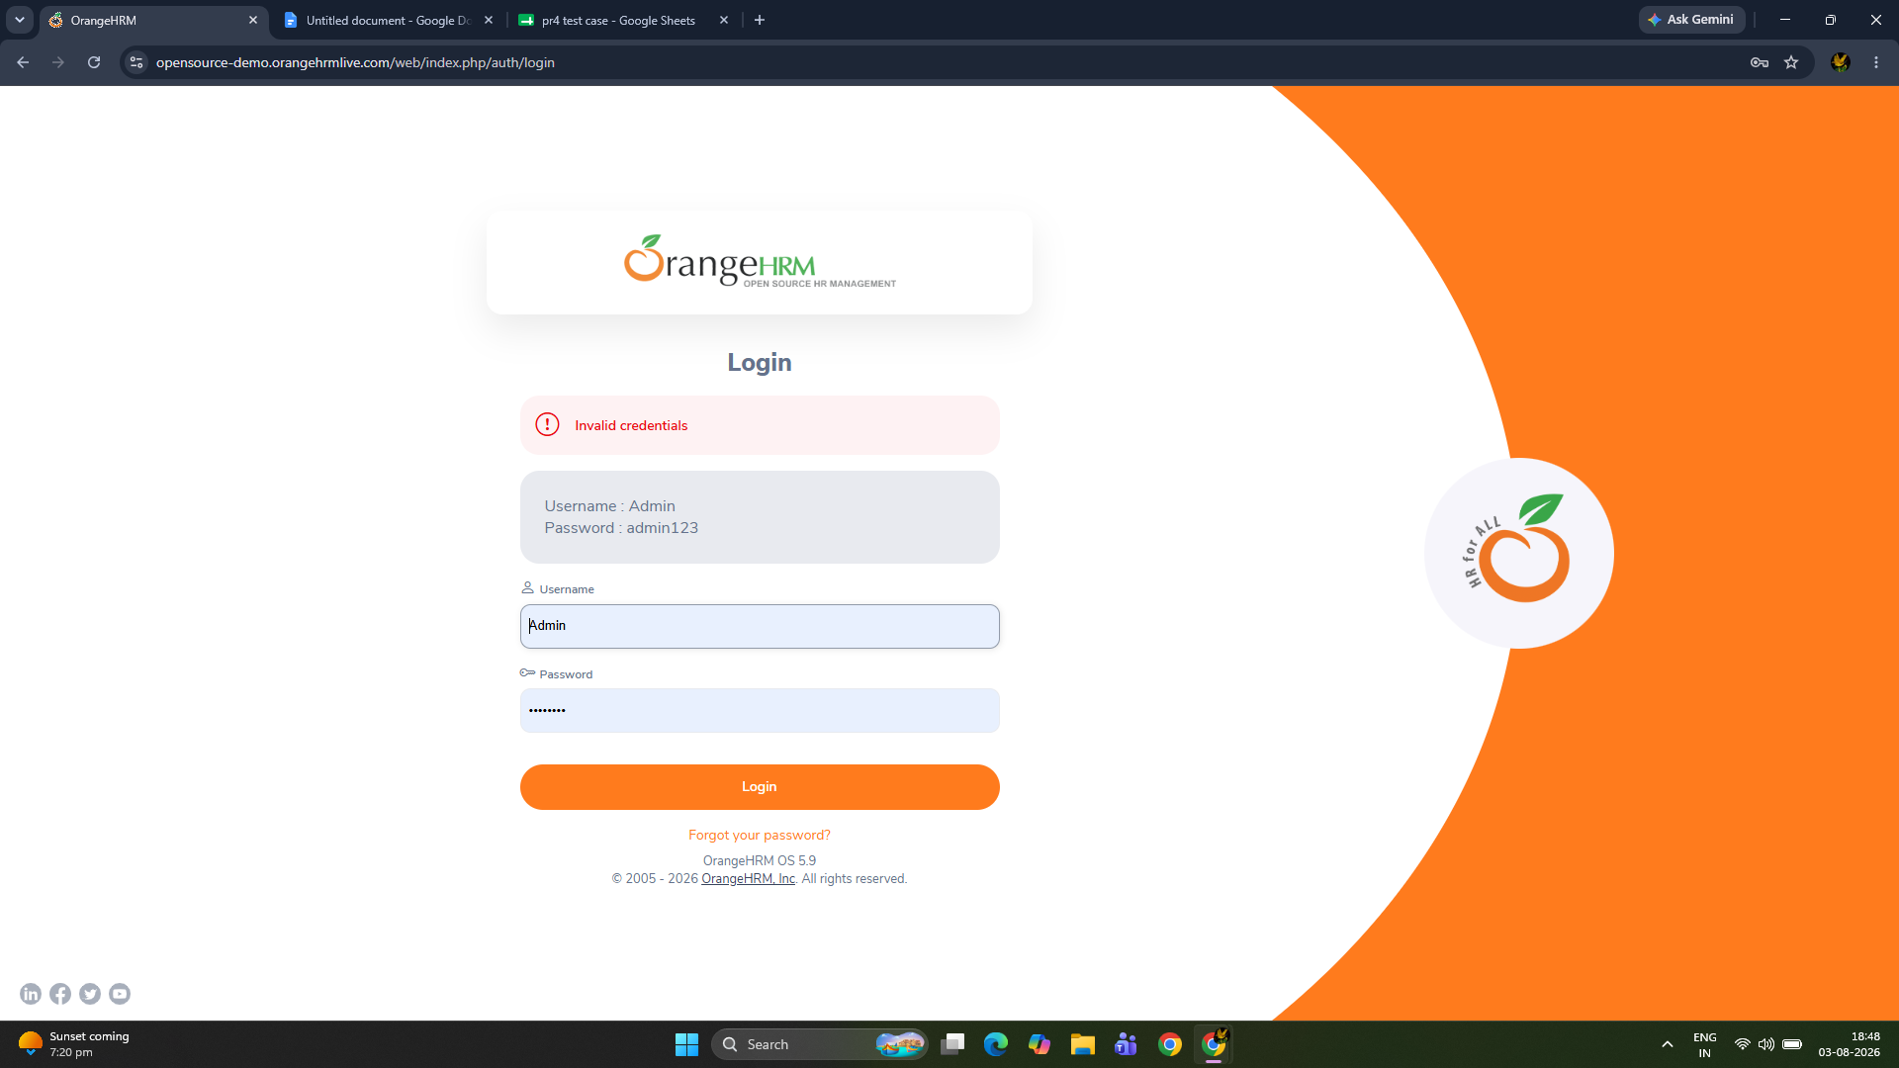

ADDING NEW EMPLOYEE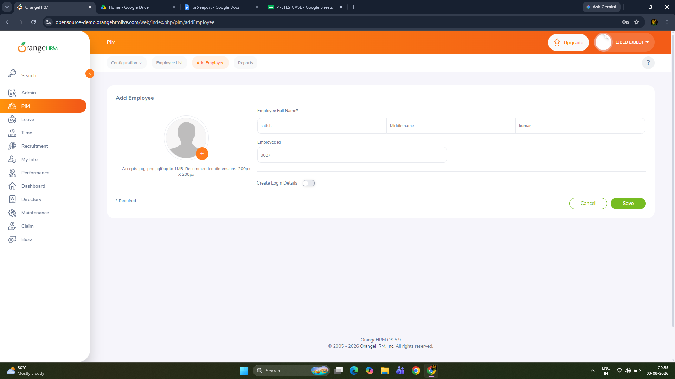
MATCHING THE EMPLOYEE DETAILS
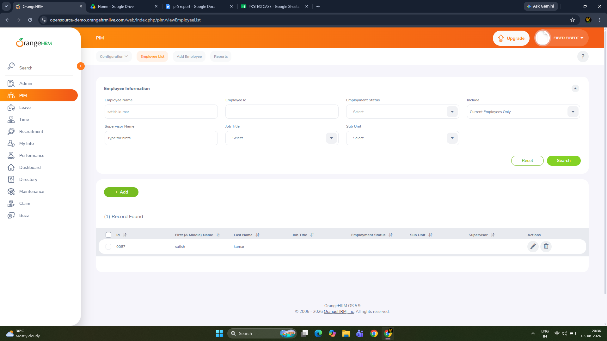

APPLY FOR LEAVE
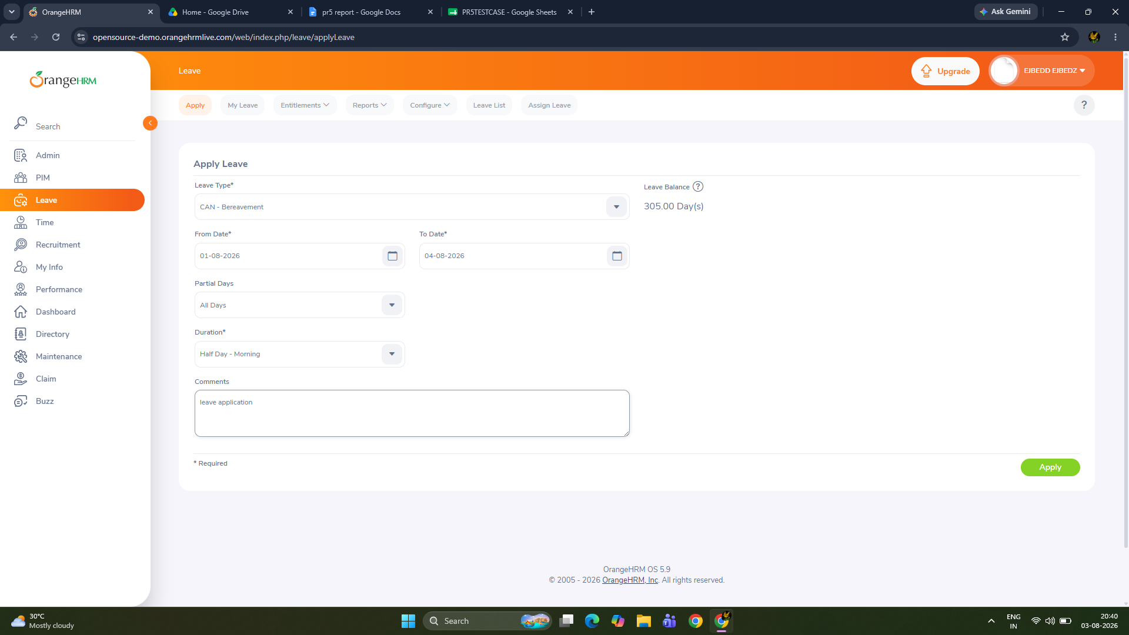

ADDING NEW CANDIDATE
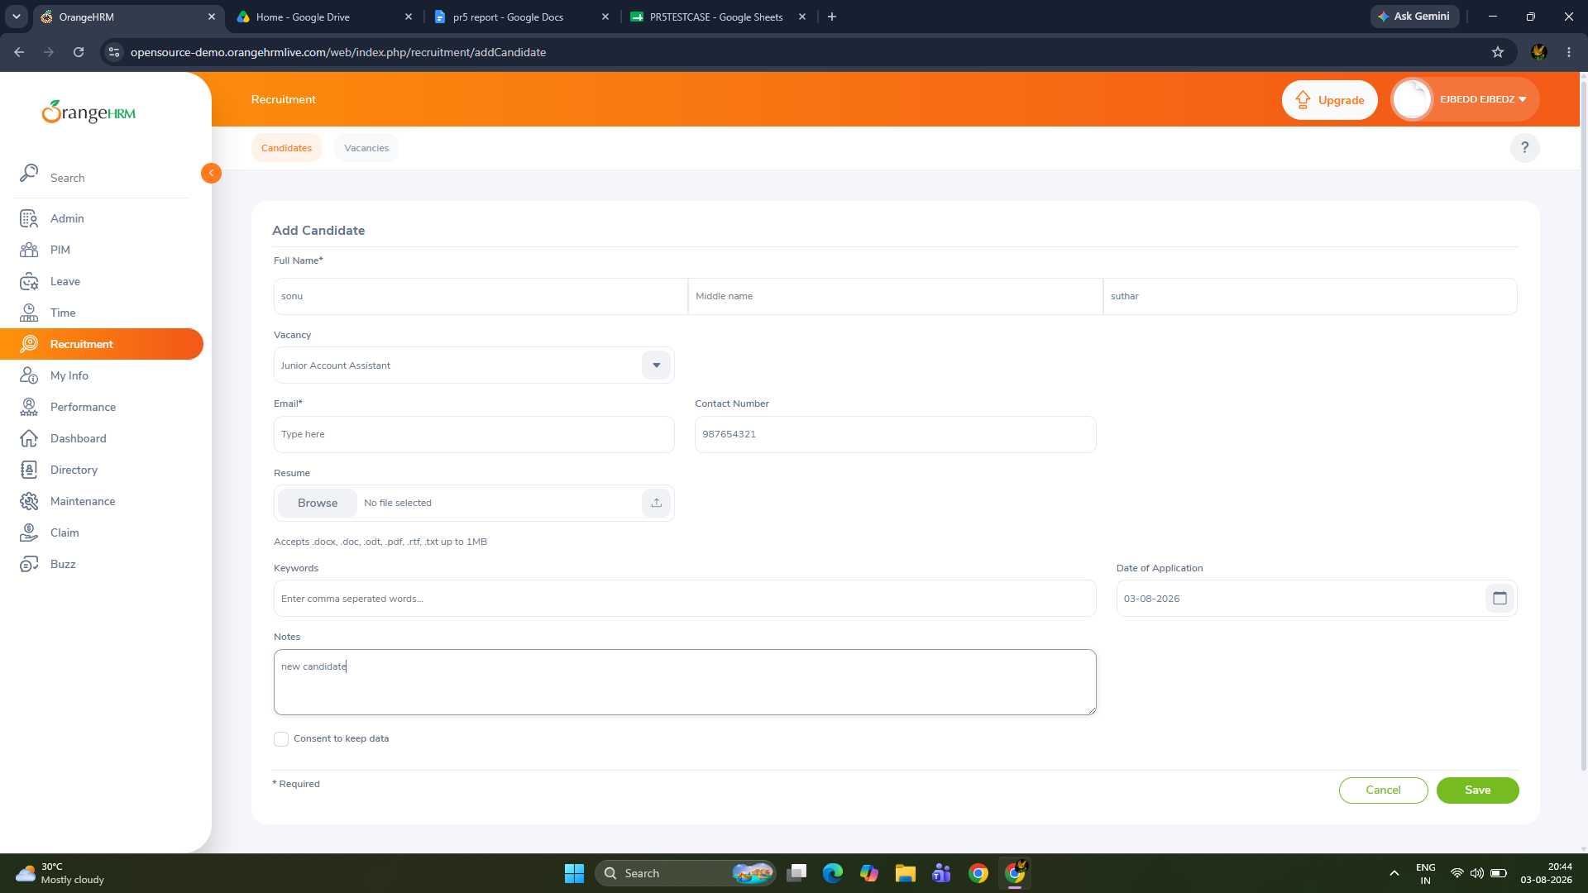

REJECTING THE CADIDATE
